# 

# Return to Space

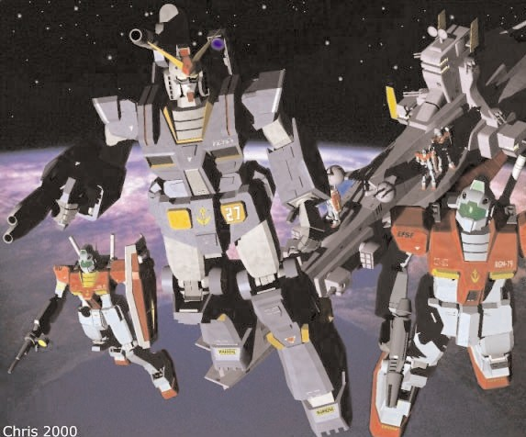

# A Brief Introduction

Mobile Suit Gundam Battle System - Return to Space is an expansion for the Mobile Suit Gundam Battle Strategy system allowing you to fight deep space battles on the tabletop between your Gundam and Mobile suit action figures or Model kits. You will need a copy of the Mobile Suit Gundam Battle System Core Rules to use the expansion presented here.

The Return to Space is a supplement to the Ground War rules represented in the core MSGBS. With this expansion, we move in a new direction – we focus on the harsh and disorientating combat that took place in space within the Gundam universe. Now you can send your own teams of Mobile Suits into the sea of stars by taking command of Federation Mobile Suit wing or units of the Zeon Mobile forces. The RtS expansion also introduces two new units to the mix: Space Fighters and Mobile armors (Mobile armors will be released with their own datasheets!).

Before we continue, please note well: the Return to Space rules are not a rework of the MSGBS. Points made in those plug-in rules still apply here unless the expansion rules explicitly dictate otherwise. Also: unless it’s mentioned in the plug-in rules, follow all the rules for shooting, combat and movement that the core rulebooks specify. Have fun!

# Rolling for Initiative

The turns in MSGBS are divided into three phases - Movement, Shooting and assault. When using ground combat rules, each player went through his phases then it was the other player’s turn. In space, things move a lot quicker; it’s easier to lose sight of your opponent in the depths of space or be disorientated by the openness of the combat. Both players now take their turn at the same time and must roll a D6 at the start of each phase - the highest scorer then chooses if he wants to go first or second.

For example: *It’s the movement phase, Mark and Henry roll a D6 each, Mark scores a 3, while Henry scores a 4. Henry wins the Initiative and can now choose to move first or second. The shooting phase is next and again they roll off. This time, Mark wins and chooses to shoot first.*

# Movement

The biggest change in the Return to Space (also referred to as RtS) is the movement values. In the Ground War rules, all suits moved more or less at the same speed. In space, however, some suits are faster, more agile, or more simply balanced differently than others. Therefore, all Mobile Suits now have their own individual movement characteristic which is recorded on the suit profile. This represents how agile the suit and how well it can move in the gravity-free environment of space.

However, no matter how free the movement is in Space, all suits still have to combat inertia, g-forces, and the fact that everything in space is moving all the time. Here are the general rules governing movement and turning in space:

|  |
| --- |
| Mobile Suits  May turn at any time, the movement cost to turn is set out below. |
| 2” to turn 45° |
| 3” to turn 90° |
| 5” to turn 180° |

For example: *A GM’s move rate is 12” - the Pilot uses 6” inches to boost forwards towards a piece of space debris and then executes a 90 degree turn which costs him an additional 3” movement - taking the total to 9”. The last 3” are used to boost the suit behind the space debris.*

Note - *Space is a 3D combat environment apart from turning and keeping station. A Mobile suit may find itself flying up and over terrain. Measure the distance it take the suit to climb the obstacle vertically and subtract it from the movement (vertical movement does counts as straight line movement for working out modifiers). If the suit doesn’t clear in that turn, it can be assumed it is still climbing and will finish its ascent in the next turn.*

**Keeping Station**

There are weapons that are fired which require a Mobile Suit to stay still, or maybe they are keeping station. The Suit doesn’t move and all its movement is used up to keep it in place. A suit that keeps station cannot assault in the assault phase.

**Fullburn**

Mobile Suits are designed with sophisticated inertia systems which activate automatically in to stop the pilot from becoming a bloody stain in his cockpit if he accelerates too hard. The speeds represented on the Mobile Suits profile are its ‘safe’ combat speeds. Mobile Suits are capable of pushing way past their safety limits if the pilot chooses to override his inertia controls. To do this the Pilot must make a successful PS. He can then add an additional 2D6” to his movement.

For that turn, the Mobile Suit moves its full distance, including its Fullburn movement, in one direction. It cannot turn, shoot, or use the movement to enter an assault, nor can it be assaulted. The benefits, apart from being able to move very fast, are that the Mobile Suit receives a 3+ saving throw against all shooting attacks. In the following turn the Pilot must make another PS check to decrease his speed and move normally. If he fails, the Mobile Suit moves at Fullburn rate as last turn. If the suit moves off the table it is considered lost for the entire battle.

**Stunned and Facing**

On occasion, Mobile Suit Pilots get stunned or lose control of their suits. This is normally happens when the suit is damaged - apply the result on the damage chart.

A suit’s direction is determined by the way the head is pointing. This is the direction the suit is assumed to be going for all movement purposes.

**Assaulting**

All Mobile suits can move an additional 6” in the assault phase if they are within 6” of an enemy Mobile Suit. This represents the pilot using an extra boost to charge into action. He gains an additional attack bonus for this action as described in the close-combat section of the Warhammer 40,000 rulebook. He still has to use the movement chart to govern turns.

# Mobile Suit Shooting

Mobile Suits must fire their weapons against a single target unless the Suit specifications allow the pilot to pick out multiple targets. In addition, if the Suit is moving, the Pilot can only activate and use one weapons system at a time, unless they remain still: then they can use up to two different weapons systems. It is also important to remember that Mobile Suits have a 270 degree fire arc but cannot fire at targets behind them, even in space.

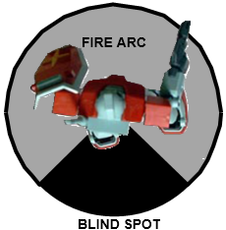

Mobile suits are capable of moving and shooting at the same time. Unless they using a heavy or ordinance weapon which they must remain still to shoot, the represents the suit bracing against the weapons recoil. If you are moving at the firing at the same time this effects targeting due the suit jolting – the faster you go the harder it becomes to target your enemy. Of course this works the other way too the faster you go the harder it is for your enemies targeting system to get a lock on you.

|  |
| --- |
| **Modifiers** |
| +1 if the target/firer is stationary |
| -1 if the target/firer moves up to 6” |
| -2 if the target/firer moves up to 12” |
| -1 if the target is in quarter cover |
| -2 if the target is in half cover |

When firing, first determine if the weapon is in range, then find the score you need to hit and roll a D6. Apply the following modifiers. If the modifiers take you below the to-hit score you fail to hit your target. If the modifiers take you above the to-hit score then you hit. As long as you make the to-hit roll you will hit your target. These modifiers are accumulative also don’t forget to check your weapons profile as they normal have a modifier to apply according the range to the target.

**The Rule of One and Six**

You may notice looking at the modifiers there are times when you won’t be able to hit your target. Or that you BS skill of the pilot you’ve chosen makes it almost impossible to miss. This is where the rule of One and Six comes in, a roll of a One on a D6 always misses regardless of modification and roll of a Six always hits regardless of modification.

**Six followed by a Six, then another Six**

Space is merciless environment to fight in, the lightest piece of damage can spell disaster as internal works are exposed to the environment, and even the lightest caliber weapon can create holes big enough to create pressure loss. A Six to hit, followed by another Six rolled on a D6 results in a critical hit. Roll another dice on a 1-5 the critical is taken on the Glancing hit chart, on a Six its taken on the Penetrating hit chart.

**Shield Saves**

Almost all Mobile Suits have a layered armored shield of some description mounted on a arm or shoulder. This shield gives the Suit a degree of protection against enemy fire. A pilot can choose to take any hit – with the exception of Ordinance – on his shield if the shot is in his frontal fire arc. The shield save is 4+ on a D6, if he fails the role for armor penetration as normal. Remember shields can be used in close combat as well to ward off enemy blows

Warning! *Armored shields are very tough, put can only take so much punishment before they give. On a roll of a one regardless of shield type it cracks or shatters and is effectively useless for the rest of the game.*

**Cover Saves**

Space is vicious place to have a fire fight, with almost no LOS restrictions and the enemy can come from any direction. Cover is still vital to a Pilots survival in space. If a Mobile suit is within 6” of piece debris, asteroid, Mobile suit, Mobile armor. The Pilot can claim cover and gets the modifier depending on how much of his suit is covered.

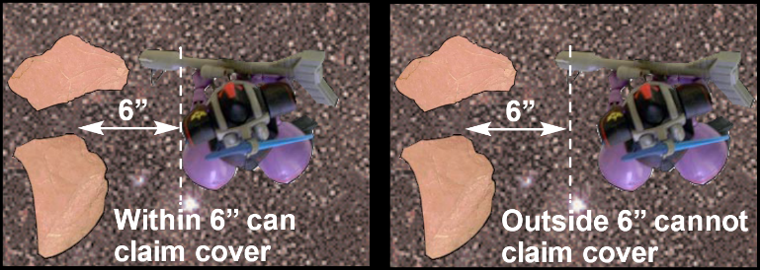

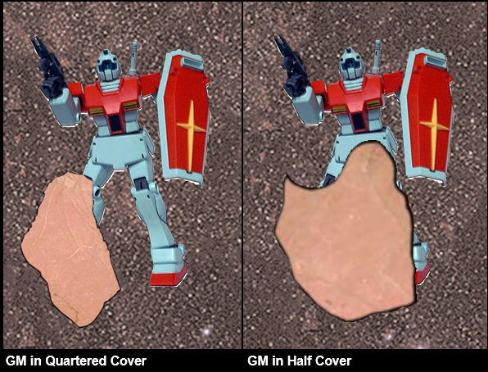

**Armor Penetration**

Once a hit is scored against a Mobile Suit roll a D6 and add the weapons Strength characteristic to it. Then compare it against the total of the Mobile Suits Armor value. Ordinance weapons fire such a huge projectile that they can smash apart armor with ease or turn the pilot to mush with the concussive force. When you roll for an Ordinance penetration roll two dice and pick the highest result.

If the total is less than the Suits armor value the shot bounces off.

If the total is equal to the Suits armor value the shot causes a glancing hit.

If the total is greater than the Suits armor value the shot causes a penetrating hit.

For Example. *The GM’s 100mm hits the Zaku twice on the front armor arc, the Zaku pilot makes his shield save for one of the shots, but the other makes it through. The GM pilot roles for penetration. The armor value of a Zaku’s front armor is 12. Rolling a D6, the pilot scores a 4, and adds this to the 100mm strength of 6 for an armor penetration total of 10. This is less than the armor value of the Zaku and so the shot bounces off.*

**Mobile Suit Armor Value**

Armor Values are different on each type of Suit. They represent the strength and thickness of the alloy used to armor up the Suit. Armor values on Mobile Suits also differ depending on whether the shot hits the front, side or rear.

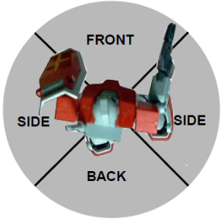

**Pilot Concussion**

Mobile Suits can absorb a great amount of damage before collapsing. However the pilots inside cannot and they suffer the effects of the concussive force of the weapons used against them. Any hit that scores an armor penetration total of 11 or more regardless of penetration the pilot must take a PS roll or count as stunned next turn. Concussion is ignored if the pilot is in close combat as the desperation to stay alive overrides any pain caused.

**Damage Rolls**

If the Mobile Suits armor is breached make a Damage roll to see what happens. Roll a D6 and look up the result on the appropriate Damage Table. Please note there are separate Damage tables for glancing and penetrating hits and these are different to the ones in the Ground War rules.

*Note on Stun and shaken results – Do not add them together you can only get stunned and shaken once per turn. These results are not accumulative.*

*Note on Immobilized results – An immobilized suit cannot turn in place and if it received a second immobilized result its weapon are jammed pointing in the direction they last fired. Weapons jammed in place can only fire at units directly in their line of fire. A third result and the suit cannot fire any weapons and counts as destroyed (result four on the chart) for the rest of the game.*

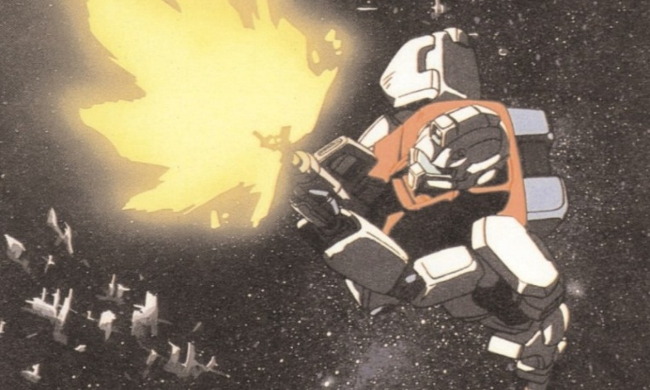

|  |
| --- |
| Glancing Hit Table – Roll a D6 |
| 1 Shaken – May not shoot next turn |
| 2 Stunned - May not shoot and the Mobile suit moves out of control in a 3D6 random direction next turn. Can make shield saves as normal. |
| 3 Limb Destroyed – Roll a D61-3 Leg - Suit loses 3” movement for each leg destroyed4-6 Arm -Suit loses 2” movement of each arm destroyed Roll a D6 to determine which arm and then apply the effect1-3 Left Arm – Shield destroyed4-6 Right Arm – Weapon destroyed |
| 4 Weapon Destroyed – A weapon chosen by the opponent is destroyed and can no longer be used |
| 5 Vernier Hit – Roll a D6. On a 4+ the boosters do not work this turn. The suit moves at the same speed as last turn and in the same direction. If the suit leaves the table it counts as destroyed for Victory point purposes. |
| 6 Auto-Balance Destroyed - Not that important in space, but it is keyed into the suits inertia systems. All movement remains the same the Pilot counts as stunned as he attempts to control of the suit. |

|  |
| --- |
| Penetrating Hit Table – Roll a D6 |
| 1 Vernier Hit - Roll a D6 on a 4+ the boosters don’t work this turn. The suit moves at the same speed as last turn and in the same direction. If the suite leaves the table it counts as destroyed for Victory point purposes. |
| 2 Auto-Balance Destroyed - Not that important in space, but it is keyed into the suits inertia systems. All movement remains the same the Pilot counts as stunned as he attempts to control of the suit. |
| 3 Limb Destroyed – Roll a D61-3 Leg - Suit loses 3” movement for each leg destroyed4-6 Arm -Suit loses 2” movement of each arm destroyed. Roll a D6 to determine which arm and then apply the effect1-3 Left Arm – Shield destroyed4-6 Right Arm – Weapon destroyed |
| 4 Head destroyed – Suit can only see using its Gun Camera, all movement is halved and WS, BS & I are at -2 |
| 5 Disabled - Suit is a junked heap - the suit will drift at 2d6” in the last direction it faced until it leaves the table or is destroyed. |
| 6 Destroyed - Suits reactor is hit and goes nova. The resulting explosion causes a 3D6 radius blast measured from the center of the Suit. Any Mobile Suit or caught in the explosion suffer a glancing hit on a 2+ and a penetrating hit on a 5+. Fighters roll on their damage table on a 3+ if they are caught in the explosion. |

# Mobile Suits in Assaults

Mobile Suits fight a little differently in space. Follow the rules as described in the Mobile Suit Gundam Battle System Core Rules with the following exceptions.

**Hit & Run**

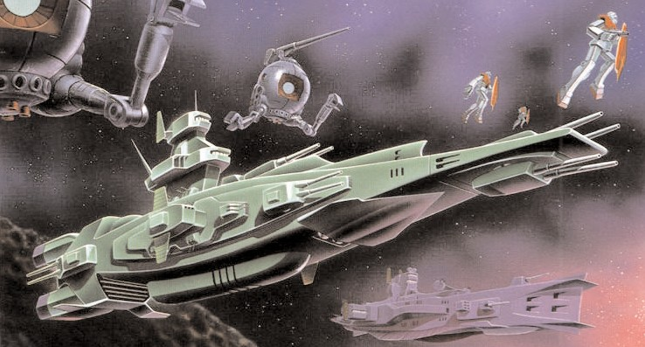

After each round of close combat, the suits move apart 4" and count as disengaged from combat. This means the suits can move as normal next turn. This represents the more hit and run nature of close combat in space.

**Immobilized**

Suits that are immobilized can still fight as normal. Their attack characteristic is reduced by –1 for each Immobilized result received.

**Hand-to-Hand Multiple Combats**

There are occasions were a Mobile Suit is up against more than one opponent. Pilots may choose to split their attacks against their opponents or concentrate on one assailant.

**Losing Combat**

If neither Mobile Suit hasn’t been destroyed in the resulting combat, then the Mobile Suit that has scored the largest number of hits (that’s hits, they don’t have to penetrating or glancing hits) will win the combat (imagine the opponent being driven back by the series of blows).

His opponent has to make an immediate leadership test or Fall Back against his opponent. If the combat is a draw roll for morale as normal.

**Fall Back & Crossfire**

If a Mobile Suit Pilot fails his leadership role he will retreat in the same way as described in the Core rulebook. Note you cannot crossfire a Mobile Suit and if pursued, and caught the pursuing Pilot get a free back against the rear armor. If the pursued suit survives this free attack he has to turn and face his attacker again.

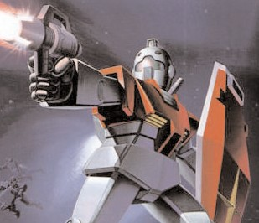

**Close Combat Weapons**

Mobile Suits are usually armed with close combat weapons be it Beam sabre or Heat Hawk. These weapons add their own bonuses onto the strength of the Suit. So when you hit work out penetration as normal. A Mobile suit armed with two close combat weapons gains an extra attack, but cannot use its shield save.

**Additional Close Combat Weapons**

Although some suits are armed with two close combat weapons, like for example 2 Beam Sabres. Mobile suits lack the basic automated coordination needed to use both weapons at the same time. A Mobile Suit can only use one Beam Sabre at a time.

*Good luck Pilots, check your weapons and stay sharp. You are ready to start fighting in unforgiving climate of Space. Be sure to check out Fighter rules and the Federation & Zeon Space Force list for your Suit specs and your pilot’s abilities. Use your forces wisely and watch your six Commander. That is all*

**

# A Brief Introduction - Star Fighters

The Star-Fighters introduces a new element to the Mobile Suit Battles - Fighters. At the beginning of the OYW the Fighter played a major role in the raging space battles. It is certain if it wasn’t for the courage of the Federation Pilots the Fleets losses would have been a lot worse. The same could be said for the Zeon pilots, flying combat missions alongside Zakus and suffering the same attrition as their Federation counterparts Halfway through the OYW and the introduction of Mobile Suits, the Fighter appeared redundant. Many Aces were retrained to use Mobile Suits and the Fighter was resigned to mundane escort and patrol work.

With the Federation returned to space, the Fighter was pressed back into frontline service, flying recon missions and in support of Mobile Suit teams. Although not as powerful as Mobile suit or as heavily armored. Fighter Pilots were just as determined to up hold their heritage and prove their worth as combat units.

### Movement

Fighters move a lot differently than Mobile Suits, they are a lot faster than MS, but suffer when it comes to maneuverability. The Pilot inside has to combat inertia, g-forces and does not have the verniers to perform maneuvers like a Mobile Suit.

Each type of Fighter has different movement value which is in their profiles. Here are the general rules governing movement and turning in space.

|  |
| --- |
| **Star Fighters** |
| Must move a minimum of 4” before turning and must move a minimum of 3” before turning again, the movement cost to turn is set out below. |
| 3” to turn 45 degrees |
| 5” to turn 90 degrees |
| 9” to turn 180 degrees |

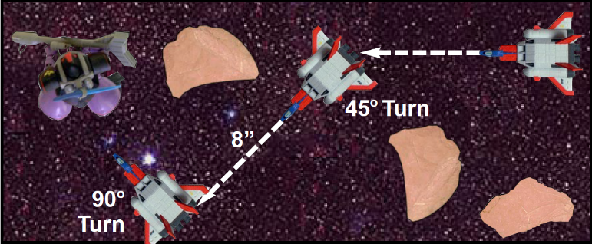

For example: *A Core Boosters move rate is 24” - the Pilot uses 8” inches to move forwards and then executes a 45 degree turn which costs him an additional 3” movement to avoid some space debris (total 11” movement). The Fighter then moves forward another 8” and executes 90 degree turn. so the Core Booster can target the weaker rear armor of an enemy Mobile Suit. Total movement is 24”.*

Note - *Space is a 3D combat environment apart from turning and keeping station. Even a fighter may find itself flying up and over terrain. Measure the distance it take the fighter to climb the obstacle vertically and subtract it from the movement (vertical movement does counts as straight line movement for working out modifiers). If the Fighter doesn’t clear in that turn, it can be assumed it is still climbing and will finish its ascent in the next turn.*

**Keeping Station**

A Star-Fighter is unable to keep station in the same way as Mobile Suit. The pilot can fire all his retros if he takes a successful PS role. Even on full retro, but Fighter will still drift 2” in the last random direction. If the Pilot fails his PS role the Fighter counts as stunned for the next turn.

**Fullburn**

Star-Fighters are designed with sophisticated inertia systems much like Mobile Suits. This system cuts in to stop the pilot from becoming a bloody stain in this cockpit, if he accelerates too hard. The speeds represented on the Fighters profile is its ‘safe’ combat speed. Fighters are capable of pushing way past their safety limits if the pilot chooses to override his inertia controls. Do this the Pilot must make a successful PS, he can then add an additional 2D6” to his movement.

For that turn the Fighter moves its full distance including its Fullburn movement in one direction, it cannot turn, shoot, or be assaulted. Apart from being able to move very fast, the Fighter receives a 4+ saving throw against all shooting attacks. In the following turn the Pilot must make another PS check to decrease his speed and move normally. If he fails the Fighter moves at Fullburn rate as last turn. If the suit moves off the table it is considered lost for the entire battle.

**Stunned and Facing**

On occasion Fighter Pilots get stunned or lose control of their suits. This is normal happens when the Fighter is damaged, apply the result on the damage chart.

A Fighters facing is determined by the way the nose or cockpit is pointing, this is the direction the Fighter is assumed to be going for all movement purposes.

**Collisions**

Mobile suit pilots try not to collide unless, of course, the collision is a deliberate close combat attack. Fighters can collide with objects, normally this is lethal for the pilot concerned. To deliberately collide with an object the pilot must pass a leadership test at +4 to the dice. If he fails the pilot chickens out (quite wisely). If he passes he can go kamikaze.

A collision occurs when part of a Star Fighter touches another object. However the collision happened here is how you work out damage. The Ramming Fighter does D3 hits at strength equal to its front facing armor +2.

Example: *A Core Fighters ramming strength is 5 +2 = 7*

The Rammer takes D6 hits at strength to its target armor facing armor +2 up to the strength 10. All space debris is assumed to have armor 8 all round.

# Fighter Shooting

Fighters must fire their weapons against one target, and cannot pick out multiple targets. In addition the Pilot can only activate and use one weapons system at a time Fighters also have a more limited 90 degree fire arc to the front and cannot fire outside that arc.

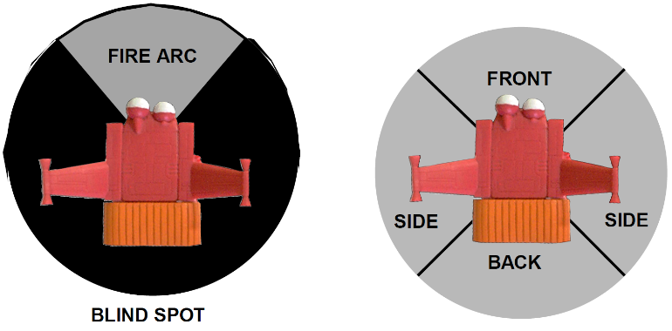

# Fighter Assaulting

Fighters cannot assault, but they can be assaulted. They are subject to the same rules as vehicles. They are automatically destroyed by the assaulting mobile suit. It is assumed that if a mobile suit can catch a fighter, it will simply crush it with one of its manipulators.

**Fighter Armor Values**

Fighters follow the same rules for armor values as mobile suits and vehicles. Armor Values are different on each type of Star Fighter. They represent the strength and thickness of the alloy used to armor up the Fighter. Armor values on Fighters also differ depending on whether the shot hits the front, side or rear.

**Damage Rolls**

If the Fighters armor is breached make a Damage roll to see what happens. Roll a D6 and look up the result on the Damage Table. Please note there is only one damage chart for Fighters.

If a glancing hit is rolled, the fighter rolls on the chart but does not lose a Hull Point. If a penetrating hit is rolled, the fighter loses a hull point and rolls on the chart.

|  |
| --- |
| **Fighter Damage Chart – Roll a D6** |
| 1 **Shaken –** May not shoot next turn |
| **2 Stunned –** May not shoot next turn and the fighter moves 3D6 in a random direction next turn |
| **3 Booster Unit Hit –** Roll a D6. On a 4+ the booster cuts out and the fighter moves in the same direction and speed as it did last turn. The fighter cannot make any turns and counts as destroyed if it leaves the table. |
| **4 Inertia Systems Destroyed –** The fighter’s inertial system goes out. All movement remains the same and the pilot must make a PS test every time he moves or the fighter counts as stunned. |
| **5-6 Fighter Destroyed –** The fighter is destroyed and removed from the table. Pilot ejects as normal. |



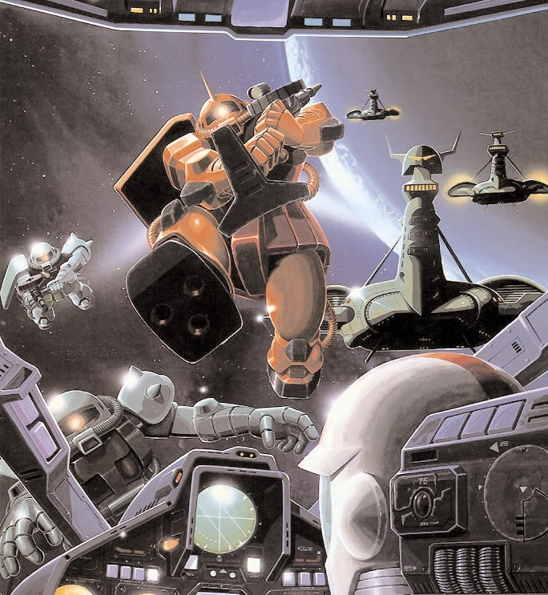

# A Brief Introduction - Using the Flight List

The Mobile Suit List is structured a little different to regular Warhammer 40,000 lists. It is split into two sections (a lot like the Armored Company list in Chapter Approved): the army list and the Mobile Suit Hanger. You use the Army list to pick the Pilots you want to make up your Team and then use the Mobile Suit Hanger to decide what type of suit your Pilot would be jockeying.

The reason for this system is simple – many of the Pilots on the list can pick from a number of different types of Mobile Suit. This cuts down repetitive in the list and makes it a lot shorter.

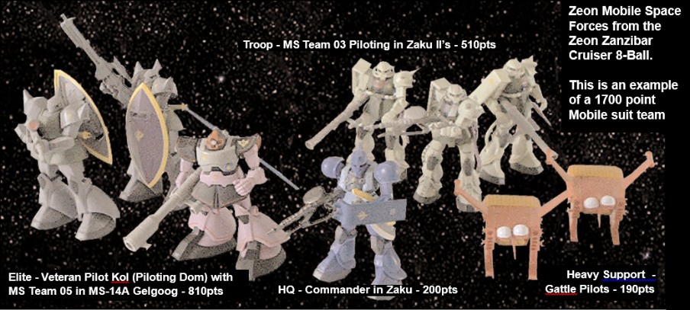

The army list are used in conjunction with the Standard Mission force organization chart in the Core rulebook. The chart is split into five categories (HQ, Elites, Troops, Fast Attack and Heavy Support), which correspond to sections in the army list. To choose your pilot you need to look in the relevant section of the list. The entry will also tell you what types of mobile suit can be chosen for that pilot from the Mobile Suit Hanger. Refer to the Hanger to find the points cost of the Mobile Suit and the weapon options and upgrades you can get for it. Remember you cannot field Suits that are equipped with the weapons or upgrades not shown on the Mobile Suit model.

The total points cost for the unit is equal to the points noted for the Suit and its upgrades in the hanger, plus the points for the pilot in the army list. Subtract this total from your army’s total points, and then go back and make another choice. Continue to do this until you have spent all your points. Then get ready to rumble…

Important Note: The Mobile suits add additional bonuses to the Pilots profile make sure you note these on the Pilots profile, don’t forget to replace the pilots strength with the Mobile Suits strength while he is piloting the machine. Also note that Mobile suits can only be armed with one hand held mobile suit weapon system. Many Mobile Suits found in

# Earth Federation Space Force

The Earth Federation Space Forces Mobile Suit Division is organized much along the same lines as their land counterpart. They are usually based on a Mobile Carrier or a retro-fitted Federation warship in units called Wings. These Wings usually are made up of a maximum of three Mobile Suits (some ships like Mobile Carriers usually have a two Mobile suit Wing compliment). Like the land equivalents these wings are led by a Commander and they undertake patrol duties, engage and destroy missions, and even decoy missions.

The list below is designed to reflect the nature of a Mobile Suit Wing and any support units that might be assigned to them to complete their mission – such as Ball units or Star-fighters. It includes units that participated in the earliest Federation counterattacks in space as well as rarer specialist suits which made their debut in the final days of the One Year War.

# Earth Federation Space Forces

# Headquarters – Flight Leader

|  |  |  |  |  |  |  |  |  |  |
| --- | --- | --- | --- | --- | --- | --- | --- | --- | --- |
|  | **WS** | **BS** | **S** | **HP** | **I** | **A** | **PS** | **LD** | **PV** |
| Ensign | 3 | 4 | 4 | - | 3 | 2 | 8 | 8 | 25 |
| Lieutenant | 4 | 4 | 3 | - | 4 | 3 | 8 | 8 | 35 |
| Captain | 4 | 4 | 3 | - | 5 | 4 | 8 | 9 | 50 |

**Unit Size:** *One Suit*

**Mobile Suit Options:** *RX-78 Gundam, RGM-79 GM, RGM-79G GM Command, RGM-79GS GM Command Space Type, RGM 79L GM Light Armor, Core Fighter, Core Booster, or RB-79 Ball*

**Independent Character:** *The Flight Leader is an Independent Character and follows the independent character special rules in the Universal Special Rules section of the Core Rules.*

# Elite – Veteran Pilot

|  |  |  |  |  |  |  |  |  |  |
| --- | --- | --- | --- | --- | --- | --- | --- | --- | --- |
|  | **WS** | **BS** | **S** | **HP** | **I** | **A** | **PS** | **LD** | **PV** |
| Veteran Pilot | 3 | 4 | 3 | - | 3 | 2 | 8 | 7 | 20 |

**Unit Size:** *One Suit*

**Mobile Suit Options:** *RX-79, RGM-79 GM, RGM-79G GM Command, RGM-79GS GM Command Spade Type, , RGM 79SC GM Sniper Custom, RGM 79SP GM Sniper II, RGM 79L GM Light Armor, RB-79 Ball, Core Fighter, or Core Booster*

**Independent Character:** *The Flight Leader is an Independent Character and follows the independent character special rules in the Universal Special Rules section of the Core Rules.*

# Troops – Pilot

|  |  |  |  |  |  |  |  |  |  |
| --- | --- | --- | --- | --- | --- | --- | --- | --- | --- |
|  | **WS** | **BS** | **S** | **HP** | **I** | **A** | **PS** | **LD** | **PV** |
| Pilot | 3 | 3 | 3 | - | 3 | 2 | 7 | 7 | 15 |

**Unit Size:** *One Unit*

**Mobile Suit Options:** *RGM-79, Core Fighter, Core Booster, or RB-79 Ball*

**Mutual Support:** *Pilots are trained to work in concert with each other and are often too inexperienced to operate alone. Therefore Pilots must always attempt to remain within 8” of another MS unit or suffer a -1 to all Leadership tests.*

# Heavy Support – Support Pilot

|  |  |  |  |  |  |  |  |  |  |
| --- | --- | --- | --- | --- | --- | --- | --- | --- | --- |
|  | **WS** | **BS** | **S** | **HP** | **I** | **A** | **PS** | **LD** | **PV** |
| Artillery Pilot | 3 | 4 | 3 | - | 3 | 1 | 7 | 7 | 20 |

**Unit Size:** *One Suit*

**Mobile Suit Options:** *RGM-79 GM, RX-77 Guncannon, RX-77D Guncannon Mass Production Type, Core Fighter, Core Booster, or RB-79 Ball*

# EFSF Mobile Suit Hangar

A number of mobile suits which participated in the Ground War on Earth also saw use in space. These suits’ profiles are already included in the MSGBS Core rules. They maintain the same point values and options listed in the Core Rules. Their space movement values are listed below.

|  |  |
| --- | --- |
| **Core Rules Suit Movement Values** | |
| RGM-79 GM | 12” |
| RX-78-2 Gundam | 18” |
| RX-77-2 Guncannon | 10” |

Other late war suits useable in the ESFS List may be found in the Codex 0080 expansion. Those suits include space movement values already in their entries.

# RGM-79 [E] GM Early Type

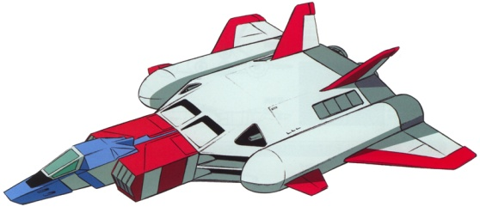During the chaotic One Year War, the Federation attempted to mass-produce a mobile suit to combat the Principality of Zeon's fearsome MS-06 Zaku II. With the RGM-79［G］ GM Ground Type already deployed on Earth, the RGM-79[E] GM Early Type would be deployed in space. The RGM-79[E] GM Early Type is an early model GM mobile suit used as a test machine to gather data for the Earth Federation's first true future mass production mobile suit. The RGM-79[E] GM Early Type's equipment was optimized for use in space. 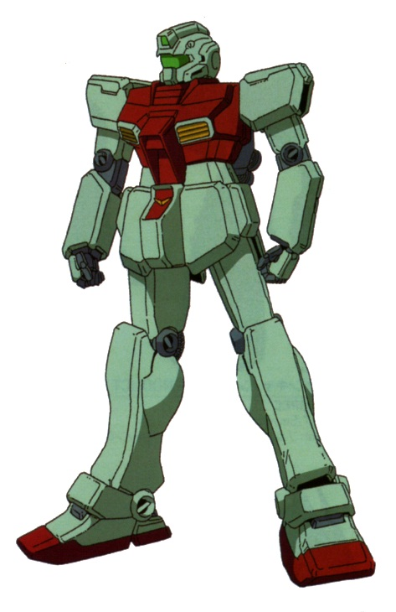

|  |  |  |  |  |  |  |  |  |  |  |  |
| --- | --- | --- | --- | --- | --- | --- | --- | --- | --- | --- | --- |
|  | **WS** | | **BS** | **S** | | **HP** | **I** | | **A** | **PS** | **LD** |
| Pilot Bonus | - | | - | 5 | | 2 | - | | +1 | +1 | - |
| **Armor Values** | | **Front** | | | **Side** | | | **Back** | | | **PV** |
| RGM-79 [E] | | 11 | | | 10 | | | 9 | | | 100 |

**Move Value** – 14”

**RGM-79 [E] GM Early Type Standard equipment & weapon:**

Twin-linked 60mm Vulcans, two beam sabres & shield

**RGM-79 [E] GM Early Type Optional equipement & weapons:**

Targeter (+5pts), beam pistol (+20pts) or 90mm machine gun (+25pts).

# FF-X7 Core Fighter

The FF-X7 Core Fighter was developed as part of the [Earth Federation](http://gundam.wikia.com/wiki/Earth_Federation)'s [Project V](http://gundam.wikia.com/wiki/Project_V) as mobile suit cockpits and emergency escape craft to increase pilot survivability and to safeguard data acquired the Earth Federation's original nine combat ready mobile suit, of which only three participated in the war. Aside from their original purpose the Core Fighter could be used as a support craft to aid mobile suit in battle either in space or in the Earth's atmosphere. Though effective fighters against the [Principality of Zeon](http://gundam.wikia.com/wiki/Principality_of_Zeon)'s [Dopp Fighters](http://gundam.wikia.com/wiki/Dopp_Fighter) and [Magella Attack Tanks](http://gundam.wikia.com/wiki/Magella_Attack_Tank) they would have limited effectiveness during the war.

|  |  |  |  |  |  |  |  |  |  |  |  |
| --- | --- | --- | --- | --- | --- | --- | --- | --- | --- | --- | --- |
|  | **WS** | | **BS** | **S** | | **HP** | **I** | | **A** | **PS** | **LD** |
| Pilot Bonus | - | | - | - | | 1 | - | | - | - | - |
| **Armor Values** | | **Front** | | | **Side** | | | **Back** | | | **PV** |
| FF-X7 Core Fighter | | 5 | | | 5 | | | 5 | | | 55 |

**Move Value –** 20”

**FF-X7 Core Fighter Standard equipment & weapons:**

Twin Linked 25mm Vulcan Gun, Twin Linked X7-Missile Launcher and Twin Linked Mega Particle Cannon.

**Special Rules:**

**Fighter:** This unit is a star fighter and follows all the rules for Star Fighter in the Return to Space rules.

# FF-X7-Bst Core Booster

The FF-X7-Bst Core Booster is essentially a regular Core Fighter with a booster system attached - in an effort to level the ground between Mobile suits and Fighters. The booster system provided additional speed and armament. Although not as common as the Core Fighter, the Core Booster found themselves being attached to the Pegasus Class Carriers and fought in all the major actions of the second part of the OYW.

|  |  |  |  |  |  |  |  |  |  |  |  |
| --- | --- | --- | --- | --- | --- | --- | --- | --- | --- | --- | --- |
|  | **WS** | | **BS** | **S** | | **HP** | **I** | | **A** | **PS** | **LD** |
| Pilot Bonus | - | | - | - | | 1 | - | | - | - | - |
| **Armor Values** | | **Front** | | | **Side** | | | **Back** | | | **PV** |
| FF-X7 Core Fighter | | 6 | | | 6 | | | 6 | | | 70 |

**Move Value –** 24”

**FF-X7-Bst Core Booster Standard equipment & weapons:**

The Core Fighter comes with this equipment and weapons as standard: Twin Linked 25mm Vulcan Gun, Twin Linked X7-MissileLauncher and Twin Linked Mega Particle Cannon.

**Fighter:** This unit is a star fighter and follows all the rules for Star Fighter in the Return to Space rules.

# RB-79 Ball

The Ball is a cheap combat vessel created to supplement the Earth Federation’s limited numbers of GM mobile suits. While planning Operation Star One, the massive space campaign which was to take the war into Zeon's home territory, the Federation decided to adapt civilian space pods into crude mobile suit 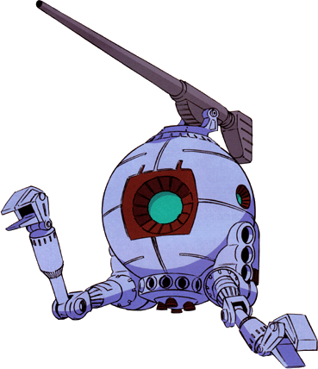substitutes. This stopgap design is based on the SP-W03, a one-man construction pod equipped with crude manipulators.

Resurrecting the previously-discarded RX-76 development plan, the Federation quickly began production of the RB-79 Ball. A limited number of RB-79K trial units were created, armed with a twin cannon turret, but the final production version sported a single 180mm cannon, and provided medium-range fire support for close-combat GM teams.

|  |  |  |  |  |  |  |  |  |  |  |  |
| --- | --- | --- | --- | --- | --- | --- | --- | --- | --- | --- | --- |
|  | **WS** | | **BS** | **S** | | **HP** | **I** | | **A** | **PS** | **LD** |
| Pilot Bonus | - | | - | 4 | | 2 | - | | - | - | - |
| **Armor Values** | | **Front** | | | **Side** | | | **Back** | | | **PV** |
| RB-79 | | 10 | | | 10 | | | 8 | | | 60 |

**Move Value –** 10”

**RB-79 Ball Standard equipment & weapons:**

The RB-79 comes with this weapon as standard: 180mm cannon.

**RB-79 Ball Optional equipment &weapons:**

The RB-79 Ball can be equipped with the following optional equipment and weapons: Targeter (+5pts), or exchange the 180mmcannon for twin-linked 150mm cannons (+10pts).



# Zeon Mobile Space Forces

The Mobile Space Forces of Zeon are an impressive force, many of their pilots are veterans of the first space conflicts at Operation British. Plus the Zeon Mobile Forces have access to a greater number of different types of Mobile Suits, compared to the GM heavy Federal forces.

As with the land forces the backbone of the Zeon force is the Zaku II mobile suit, which is adaptable, easy to maintain. Halfway through the OYW Zeon started rearming their Pilots with the impressive Rick Dom. Although by the time the Federation returned to space they were badly outnumbered the Zeon suits and Pilots always made up for quantity with quality.

# Zeon Mobile Space Forces Pilot List

# Headquarters – Commander

|  |  |  |  |  |  |  |  |  |  |
| --- | --- | --- | --- | --- | --- | --- | --- | --- | --- |
|  | **WS** | **BS** | **S** | **W** | **I** | **A** | **PS** | **LD** | **PV** |
| Lieutenant | 3 | 4 | 4 | 1 | 4 | 3 | 8 | 8 | 35 |
| Captain | 4 | 4 | 3 | 2 | 4 | 4 | 8 | 8 | 45 |
| Major | 4 | 4 | 3 | 3 | 5 | 5 | 8 | 9 | 55 |

# Unit Size: *One Suit*

# Mobile Suit Options: *MS-05B Zaku I, MS-06F Zaku II, MS-06S Zaku II Command Type, MS-0R-1 High Mobility Type, MS-06R-2 High Mobility Type, MS-09R Rick Dom, MS-14A Gelgoog, MS-14S Gelgoog Commander or Gattle*

**Independent Character:** *The Team Leader is an Independent Character and follows the independent character special rules in the Universal Special Rules section of the Core Rules.*

# Elite – Veteran Pilot

|  |  |  |  |  |  |  |  |  |  |
| --- | --- | --- | --- | --- | --- | --- | --- | --- | --- |
|  | **WS** | **BS** | **S** | **W** | **I** | **A** | **PS** | **LD** | **PV** |
| Veteran Pilot | 4 | 4 | 3 | 1 | 3 | 2 | 8 | 7 | 30 |

**Unit Size:** *One Suit*

**Mobile Suit Options:** *MS-05B Zaku I, MS-06F Zaku II, MS-06S Zaku II Command Type, MS-0R-1 High Mobility Type, MS-09R Rick Dom, MS-14A Gelgoog or Gattle*

# Troops – Pilot

|  |  |  |  |  |  |  |  |  |  |
| --- | --- | --- | --- | --- | --- | --- | --- | --- | --- |
|  | **WS** | **BS** | **S** | **W** | **I** | **A** | **PS** | **LD** | **PV** |
| Pilot | 3 | 3 | 3 | 1 | 3 | 2 | 7 | 7 | 15 |

**Unit Size:** *One Suit*

**Mobile Suit Options:** *MS-05B Zaku I, MS-06F Zaku II, MS-09R Rick Dom, or Gattle.*

# Heavy Support – Support Pilot

|  |  |  |  |  |  |  |  |  |  |
| --- | --- | --- | --- | --- | --- | --- | --- | --- | --- |
|  | **WS** | **BS** | **S** | **W** | **I** | **A** | **PS** | **LD** | **PV** |
| Artillery Pilot | 3 | 4 | 3 | 1 | 3 | 1 | 7 | 7 | 20 |

**Unit Size:** *One Suit*

**Mobile Suit Options**: *MS-05B Zaku I, MS-06F Zaku II, MS-09R Rick Dom, MS-14A Gelgoog or Gattle.*

# Zeon Mobile Space Forces Hangar

A number of mobile suits which participated in the Ground War on Earth also saw use in space. These suits’ profiles are already included in the MSGBS Core rules. They maintain the same point values and options listed in the Core Rules. Their space movement values are listed below.

|  |  |
| --- | --- |
| **Core Rules Suit Movement Values** | |
| MS-05B Zaku I | 10” |
| MS-06F Zaku II | 12” |
| MS-06S Zaku II Command | 14” |
| MS-14A Gelgoog | 16” |

Other late war suits useable in the Zeon Mobile Space For es Army List may be found in the Codex 0080 expansion. Those suits include space movement values already in their entries.

# ms-06r-1a.jpgMS-06R-1A Zaku II High Mobility

After the successful release of the MS-06R-1 Zaku II High Mobility Test Type the Zeon engineers began to receive feedback from the pilots of the new units on ways the design of the mobile suit could be further improved upon. The new ideas were incorporated into the next release of the MS-06R-1A Zaku II High Mobility Type. The Zaku II High Mobility Type had some minor engine problems corrected, and the larger capacity propellant tanks were removed and replaced with exchangeable fuel cartridges, which were much quicker to reload and refuel.

|  |  |  |  |  |  |  |  |  |  |  |  |
| --- | --- | --- | --- | --- | --- | --- | --- | --- | --- | --- | --- |
|  | **WS** | | **BS** | **S** | | **W** | **I** | | **A** | **PS** | **LD** |
| Pilot Bonus | - | | - | 5 | | - | - | | +1 | +1 | - |
| **Armor Values** | | **Front** | | | **Side** | | | **Back** | | | **PV** |
| MS-06R-1A | | 11 | | | 10 | | | 9 | | | 140 |

**Move Value –** 15”

**MS-06R-1 Zaku II High Mobility Test Type Standard equipment & weapons:**

Shield, heat hawk & cracker grenade

**MS-06R-1 Zaku II High Mobility Test Type Optional equipment & weapons:**

Targeter (+5pts), Large Heat Hawk (+50) 120mm machine gun(+40pts), 280mm Bazooka (+45pts, or 360mm super-bazooka (+55pts)

# MS-06R-2 Zaku II High Mobility

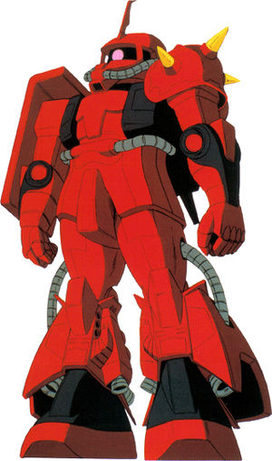The Zaku II High Mobility Type was originally intended as a space use replacement for the old Zaku II, part of many MS development programs. Due to the cancellation of the MS-11 Action Zaku in favor of development of the MS-14 Gelgoog, the Principality of Zeon needed modern space borne MS as a temporary replacement. Zeonic Company's bid was the MS-06R-2 Zaku II High Mobility Type. The R-2 Zaku was much lighter than its R-1A predecessor, featured increased storage for propellant, and had extra armor on the legs. However, the fact that the R-2 used the R-1A's reactor meant that it could not use beam weapons. Only four units were produced before the MS-09R Rick Dom was chosen as the new space combat MS.

|  |  |  |  |  |  |  |  |  |  |  |
| --- | --- | --- | --- | --- | --- | --- | --- | --- | --- | --- |
|  | **WS** | | **BS** | **S** | | **W** | **I** | **A** | **PS** | **LD** |
| Pilot Bonus | - | | - | 5 | | - | +1 | - | +1 | - |
| **Armor Values** | | **Front** | | | **Side** | | | **Back** | | **PV** |
| MS-06R-2 | | 12 | | | 11 | | | 10 | | 180 |

**Move Value –** 16”

**MS-06R-2 Zaku II High Mobility Standard equipment & weapons:**

Shield, heat hawk & cracker grenade

**MS-06R-2 Zaku II High Mobility Optional equipment & weapons:**

Targeter (+5pts), Large Heat Hawk (+50) 120mm machine gun(+40pts), 280mm Bazooka (+45pts), or 360mm super-bazooka (+55pts)

**Special Rules:**

**Hit and Run:** The MS-06R-2 Zaku II High Mobility is a customized suit with an emphasis on speed. To represent this, the MS-06R-2 Zaku II High Mobility may make a 6” move in the assault phase regardless of it being within 6”of an enemy.

# MS-09R Rick Dom

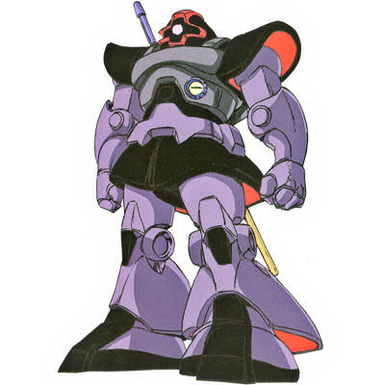The space-type version, the MS-09R Rick Dom, had the original MS-09B Dom's hover jets replaced with rocket thrusters for use outside of the atmosphere. The resulting mobile suit had superior armor, power output, thrust, and maneuverability than the MS-06F Zaku II, the mobile suit the MS-09R Rick Dom was to replace.

For combat the MS-09R Rick Dom relied on the same weapons and tactics as the ground use original. The MS-09R Rick Dom's standard armament is a 360mm bazooka which fires rocket propelled explosive rounds, giving the Rick Dom the power to destroy an enemy mobile suit in a single shot or to heavily damage an enemy warship. For melee combat the Rick Dom uses a heat saber, a rod which heats to super-high temperatures and can melt through the armor of an enemy mobile suit. The heat saber has a larger surface area to heat, which requires more energy, but the greater surface area gives it greater range, making it more effective in combat than the heat hawk used by the old F-type Zaku II. And built into the chest of the Rick Dom is a scattering beam gun, which is useless for actually damaging an enemy, but is employed as a diversionary weapon for its ability to blind an enemy's eyes and sensors for several moments.

In order to increase its combat abilities the Principality of Zeon develops an experimental beam bazooka that several Rick Doms are outfitted with. The beam bazooka is capable of dramatically increasing the offensive power of the Rick Dom but the beam bazooka is never put into mass production.

|  |  |  |  |  |  |  |  |  |  |  |
| --- | --- | --- | --- | --- | --- | --- | --- | --- | --- | --- |
|  | **WS** | | **BS** | **S** | | **HP** | **I** | **A** | **PS** | **LD** |
| Pilot Bonus | - | | - | 7 | | 3 | +1 | - | +1 | - |
| **Armor Values** | | **Front** | | | **Side** | | | **Back** | | **PV** |
| MS-09R | | 13 | | | 12 | | | 10 | | 200 |

**Move Value –** 16”

**MS-09 Standard equipment & weapon:**

Scattering beam cannon (counts as cracker grenade), jump pack, heat hawk

**MS-09 Optional equipment & weapon options:**

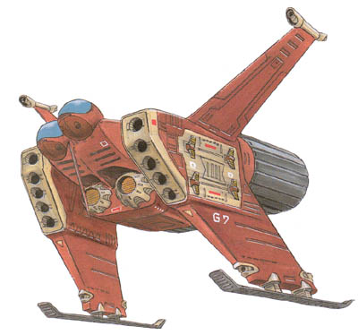90mm MMP- 70C Machine Gun (+45pts), 120mm machine gun (+35pts), 280mm Bazooka (+35pts), Panzer Faust (Single Shot) (+10pts), 360mm Super Bazooka (+65pts) or Beam Bazooka (+80pts)

# Gattle

The Gattle is a fighter-bomber used mainly for anti-ship attack. The Gattle carries four large missiles, two missiles on each side or two vulcan pods on each side. It has two 5-tube missile launcher. The Gattle has a crew of two - a pilot and a flight officer seated in side-by-side. Unlike the Gobble the Gattle has an escape cockpit for each pilot.

|  |  |  |  |  |  |  |  |  |  |  |
| --- | --- | --- | --- | --- | --- | --- | --- | --- | --- | --- |
|  | **WS** | | **BS** | **S** | | **HP** | **I** | **A** | **PS** | **LD** |
| Pilot Bonus | - | | - | - | | 1 | +1 | - | - | - |
| **Armor Values** | | **Front** | | | **Side** | | | **Back** | | **PV** |
| Gattle | | 8 | | | 8 | | | 5 | | 80 |

### Move Value – 20”

### Gattle Standard Equipment & weapons:

The Gattle comes with this equipment and weapons as standard: Twin-linked 25mm Vulcan Gun, Twin-linked 5 tube Missile launcher, 4 tube Missile launcher.

# MA-05 Bigro

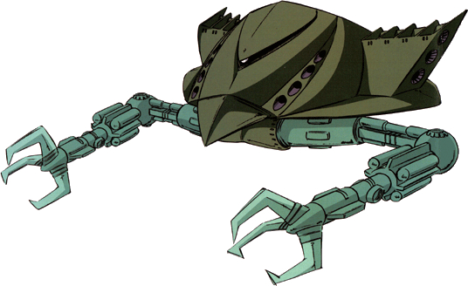In the years building up to the One Year War, several companies took part in a new conceptual weapons competition. MIP Company's entry to the competition was the experimental MIP-X1 mobile armor; however, MIP lost out to Zeonic Company's more agile and versatile mobile suit concept. As the One Year War opened and Zeon began taking a serious second look at the mobile armor concept, the MIP-X1 was taken back to the drawing board and remodeled into the mobile armor MA-05 Bigro. Mounted a pair of large claw-laden arms for limited AMBAC (Active Mass Balance Auto Control) ability, the Bigro incorporated the same mono-eye sensor system used on all Zeon military mobile suits. Driven by a pair of large nuclear rocket engines, mounting a large mega particle gun and a pair of 4-tube missile launchers, and equipped with a Minovsky particle scattering system to make it difficult to detect with sensors, the Bigro was well-proven as a high-speed anti-warship unit. However, only a handful of the costly Bigros would be produced during the war.

|  |  |  |  |  |  |  |  |  |  |  |
| --- | --- | --- | --- | --- | --- | --- | --- | --- | --- | --- |
|  | **WS** | | **BS** | **S** | | **HP** | **I** | **A** | **PS** | **LD** |
| Pilot Bonus | - | | 1 | 9 | | 4 | 1 | 1 | - | - |
| **Armor Values** | | **Front** | | | **Side** | | | **Back** | | **PV** |
| MA-05 Bigro | | 14 | | | 12 | | | 12 | | 400 |

**Move Value –** 20”

**MA-05 Bigro Standard Equipment & Weapons:**

The Big-Ro comes with this equipment and weapons as standard: Targetor, Mega-Particle cannon and twin-linked 4-tube missile launcher.

**Special Rules:**

**Hitching a Lift -** The Big-Ro is capable of carrying its own Mobile suit support. A Mobile Suit may travel on underneath of the Big-Ro gaining the additional movement of the Mobile Armor. You may start the game with two Mobile Suits riding clamped to the underneath of the Big-Ro. To dismount the Mobile Suit has to make a successful PS check or count as stunned for that turn.

To mount up during a battle the Big-Ro must be within 6” of the Mobile Suit at the start of the movement phase. The Mobile Suit then makes a PS test at -2 to see if he can grab onto the handle underneath the moving Big-Ro. If successful the Mobile suit can move at the same speed as the Big-Ro. If failed the Mobile suit and Big-Ro take an automatic glancing hit and the Mobile Suit counts as stunned for one turn.

**Mobile Armor:** This unit, though not a Star Fighter, follows the movement and shooting rules for Star Fighters. It uses the Mobile Suit Damage Tables.

**Mobile Suit Weapon Armory**

**Close Combat Weapons**

|  |  |  |  |  |  |
| --- | --- | --- | --- | --- | --- |
| Weapons | Range | Short | Long | Str | Type |
| Large Heat Hawk | - | - | - | +3 | HTH |
|  |  |  |  |  |  |

# Rapid Fire

|  |  |  |  |  |  |
| --- | --- | --- | --- | --- | --- |
| Weapons | Range | Short | Long | Str | Type |
| 100mm Machine Gun | 32” | - | - | 8 | Rapid Fire 2 |
| 105mm Machine Gun | 32” | - | - | 8 | Rapid Fire 2 |
| 120mm Machine Gun | 32” | - | - | 8 | Rapid Fire 2 |
| 90mm Machine Gun | 32” | - | - | 7 | Rapid Fire 2 |
| Beam Machine Gun | 32” | - | - | 9 | Rapid Fire 2 |

# Assault Weapons

|  |  |  |  |  |  |
| --- | --- | --- | --- | --- | --- |
| Weapons | Range | Short | Long | Str | Type |
| 20mm Vulcan Gun | 9” | +1 | - | 4 | Assault |
| 25mm Vulcan Gun | 9” | +1 | - | 4 | Assault |
| Vulcan Cannon | 12” | +1 | - | 5 | Assault 3 |

# Heavy Weapons

|  |  |  |  |  |  |
| --- | --- | --- | --- | --- | --- |
| Weapons | Range | Short | Long | Str | Type |
| X7 Missile Launcher | 12” | - | - | 5 | Heavy |
| 150mm Cannon | 48” | - | - | 6 | Heavy 2 |
| 4 Tube Missile Launcher | 24” | +1 | - | 7 | Heavy |
| 5 Tube Missile Launcher | 48” | - | - | 5 | Heavy 2 |